

**9 New Street, Clive, Shropshire, SY4 3LE**

**A recently renovated 2 bedroom terraced, period stone property set in the much sought after village of Clive.**

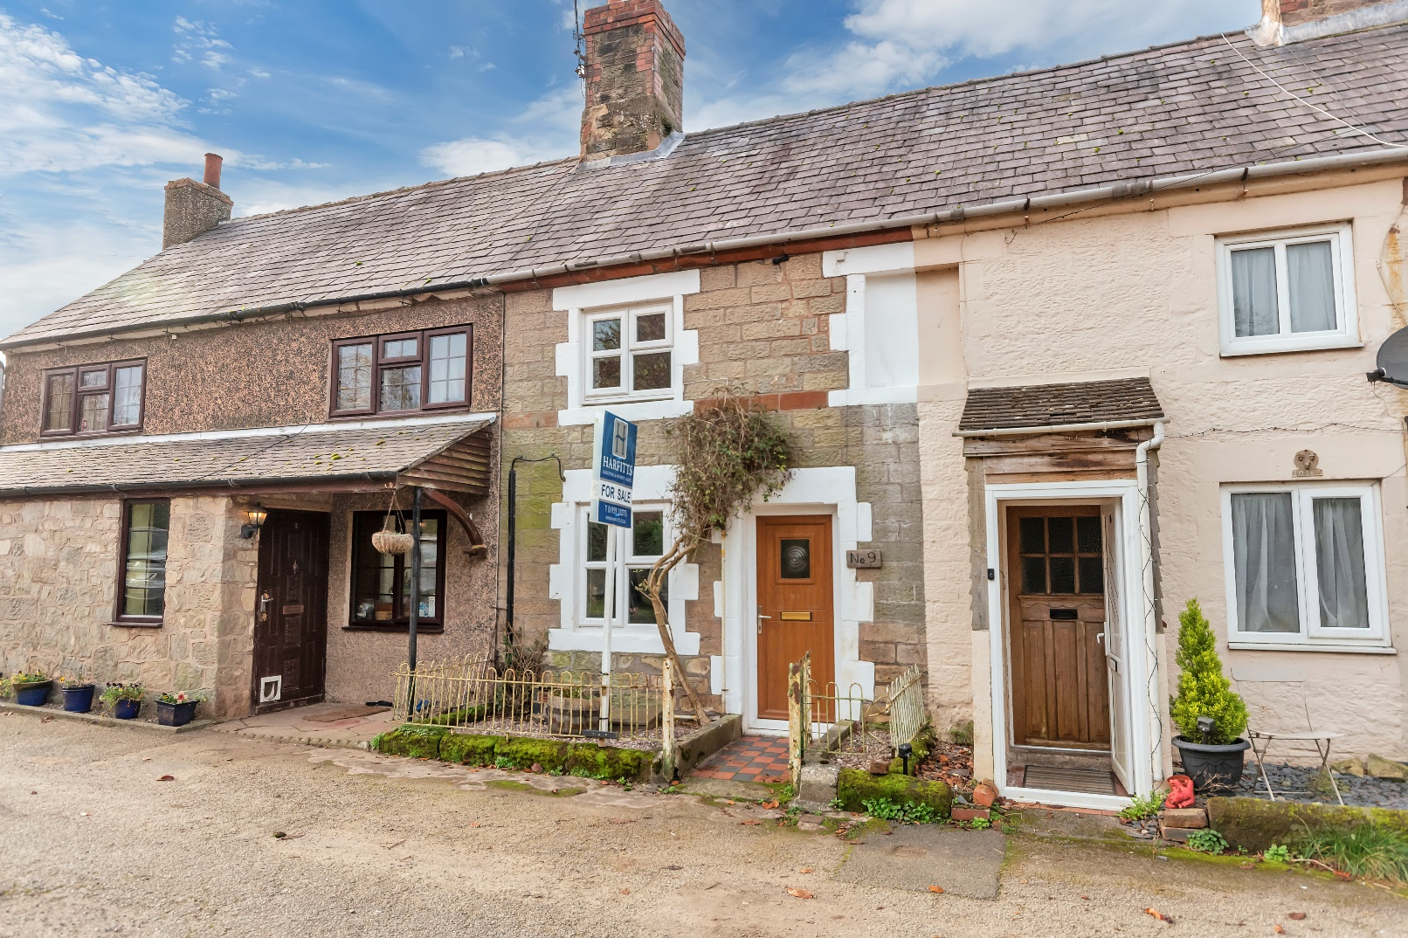

* **2 bedrooms**

**Offers around**

**£210,000.00**

* **Recently renovated kitchen / breakfast room**
* **Recently renovated bathroom**
* **Private driveway parking for 2 vehicles**
* **Rural views to the rear**
* **Sought after village location**

[www.harfitts.co.uk](http://www.harfitts.co.uk) 01939 232775

#### The Property

#### 9 New Street, Clive is a recently renovated, two-bedroom period stone property set in the very much sought after village of Clive, in North Shropshire.

#### The property is entered through a partially glazed upvc doorway to the front, leading directly into the living room with feature period Grinshill stone fireplace and hearth and new Mazona multi fuel log burner with new liner and chimney pot. Upvc double glazed window to the fore.

#### 

#### The good-sized kitchen is situated at the rear of the property with a range of new fitted wall and base units with contrasting worktops over, an integrated gas hob & electric oven and an extractor hood.

#### 

The property has also had a lighting circuit rewire and new fuse box.

[www.harfitts.co.uk](http://www.harfitts.co.uk) 01939 232775

#### 

#### There are two bedrooms one of which is a comfortable sized double.

Bedroom 1: sits at the front of the property having useful fitted pine wardrobes and cupboards in the alcove areas. Upvc double glazed window to the front

Bedroom 2: A single room overlooking the rear of the property.

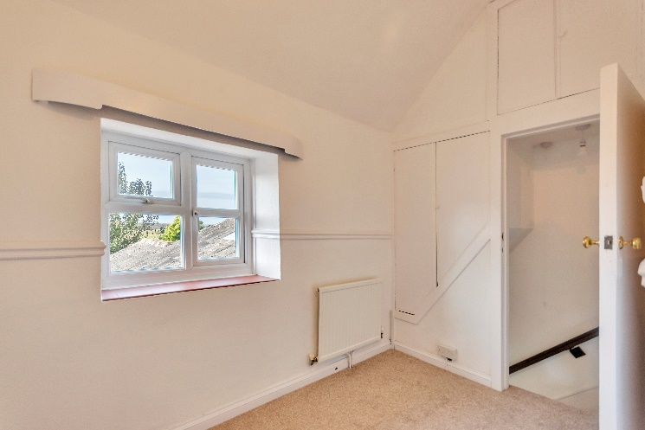

The bathroom is fitted with a new white-coloured suite consisting of a new electric shower, wash hand basin and WC with tiled walls. The window is fitted with frosted glass.

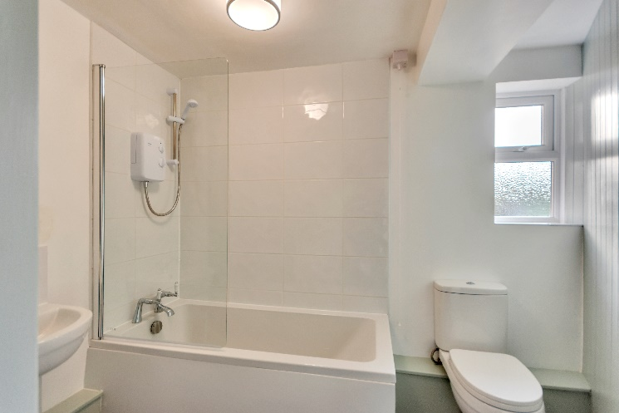

**Outside**

9 New Street is located in the lovely, much sought after rural village of Clive.

The property is approached to the front through a low-level wrought iron gateway across a quarry tiled paved pathway and gravelled area to the side.

The rear garden is a very good size and is a real asset to the property with open rural views to the rear.

A patio area laid to brick leads from the kitchen door screened from the rest of the garden by a mixture of fencing and dwarf brick walling.

Curved steps lead to the remainder of the garden which is a mixture of lawned areas and raised beds. Various outbuildings including a greenhouse, good sized shed and a variety of other structures having a number of potential uses.

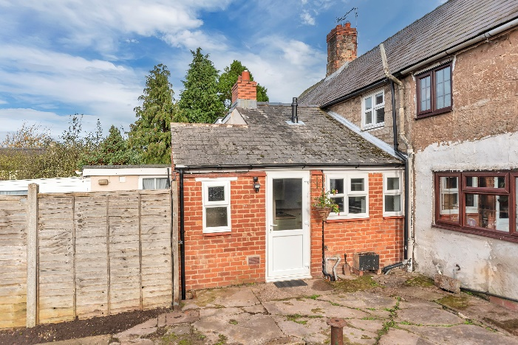

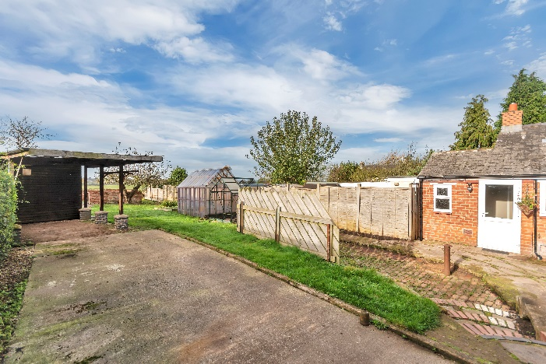

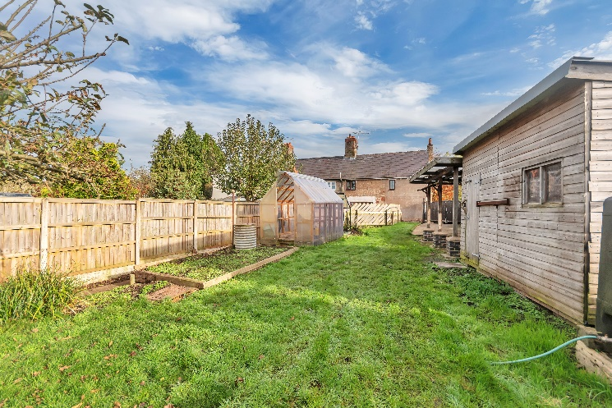

9 New Street Clive has the additional benefit of its own private driveway. The accessway is set alongside the neighbouring property. Double wooden gates provide access to the driveway to the rear garden.

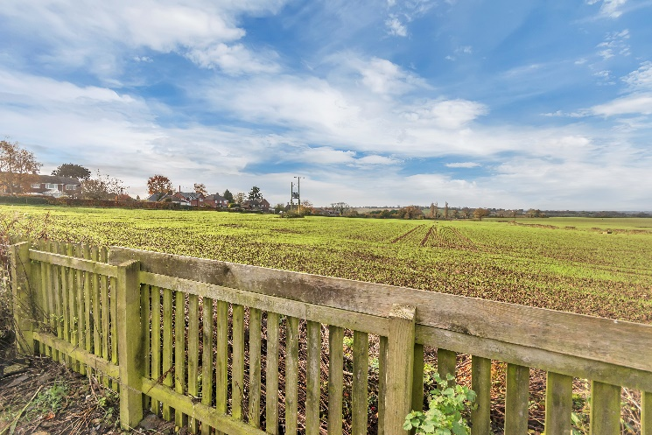

**The Local Area**

Clive is a very attractive and much sought after rural village in North Shropshire with its own primary school, village hall which holds a number of activities and church.

It is within convenient driving distance of Wem town centre and the local shops and amenities. There are excellent doctors, dentists, schools and independent shops within the town, as well as a supermarket and a selection of pubs and eateries.

The larger towns of Shrewsbury and Whitchurch are only a few miles drive away, and there are rail links directly from Wem Station to Crewe to the north, and Shrewsbury, Birmingham and London to the south.

**Council Tax Band**

B

.

**Local Authority**

Shropshire Council

**Services**

Mains water, drainage, gas and electricity. Gas fired central heating.

**Viewing**

Strictly by appointment with Harfitts.

**Tenure**

We understand the property is freehold, although purchasers are advised to confirm details with their solicitor.

All measurements are approximate and are for identification purposes only.

**VALUATIONS**

**For a free no obligation valuation of your own property please call us on 01939 232775**

**MORTGAGE ADVICE**

**We can put you in contact with expert independent financial advisors, please ask for details.**

**SURVEYS**

**Please ask us for details of local surveyors**

[www.harfitts.co.uk](http://www.harfitts.co.uk) 01939 232775

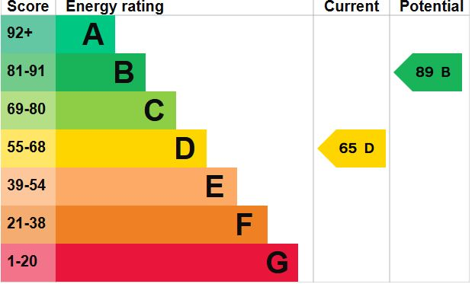

[www.harfitts.co.uk](http://www.harfitts.co.uk) 01939 232775

**Agent’s Notes**

Harfitts for themselves and for the vendors or lessors of this property, whose Agents they are, give notice that:

These particulars are produced in good faith, and are set out as a general guide and do not constitute any part of an offer or contract.

No person in the employment of Harfitts has any authority to make or give any representations or warranty whatever in relation to this property.

Harfitts take many precautions to ensure that the sale particulars are drafted accurately and that information is verified by the owners, who have checked these details and declare them true and accurate.

All measurements are approximate and are for identification purposes only.

Electrical and other appliances mentioned in these particulars have not been tested by Harfitts. Therefore prospective purchasers must satisfy themselves as to their working order.

Harfitts is a trading name of Paul F. Harfitt & Co.

[www.harfitts.co.uk](http://www.harfitts.co.uk) 01939 232775